

|  |  |  |
| --- | --- | --- |
| Mathematics Department | |  |
| Course: A1MAA | |
| Topic Title: Test 2 – Calc Assumed | |
| Student Name:_____________________________________ | Date: ____________ | | |
| Special Instructions: | Time Allowed: | | |
|  | Marks: / 40 | | |

**Question 1 (1,2,2 : 5 marks)**

A person’s Body Mass Index (BMI) is calculated using the following formula

BMI = $\frac{m}{{ h}^{2}}$ where m is the mass of the person in kg, and h is their height in metres.

Using this formula:

a) Calculate the BMI of David, who weighs 72 kg and is 1.92 m tall.

b) Calculate the BMI of Ben, who is 165 cm tall and weighs 85 kg.

c) Refer to the BMI table below and advise David and Ben if they need to lose weight.

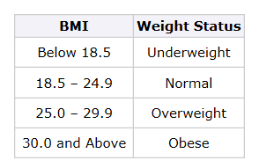

Ref: http://www.cdc.gov/healthyweight/assessing/bmi/adult_bmi/

**Question 2. (4,4 : 8 marks)**

A section of a spreadsheet, provided below, shows the number of hours worked by three students

during the course of a week. The students are paid time and a half on Saturdays and double time on

Sundays.



a) How much will Gen earn in a week?

b) Using cell references (e.g. A1 for row 1 column A), state the formula to calculate Ala’s total pay

for one week.

**Question 3. (3 marks)**

Chocolate Easter eggs are on special at a local supermarket.

The larger eggs (110g each) are advertised at ‘Two for $4’ and the smaller ones (39g) cost $1 each.

By calculating the cost per gram of chocolate, determine which size represents better value for money.

**Question 4. (4,3,3 : 10 marks)**

John wants to see which of the two banks in his portfolio of shares is the better performer, and he

decides to use the P/E ratio to compare the two banks.

 

AAA Bank’s shares are currently $33.65 while ZZZ Bank’s shares are currently $32.055.

AAA Bank has annual earnings of 207.5 cents per share.

ZZZ Bank has annual earnings of 223.1 cents per share.

a) Calculate the P/Eratio for each bank and make a recommendation as to which bank John

should buy more of, if the P/E ratio was the only indicator to be used.

Justify your recommendation.

Dividends from both banks are paid twice a year and in the last year AAA Bank gave dividends at

82c and 84c per share.

b) What percentage of its annual earnings does AAA Bank distribute to shareholders?

c) ZZZ Bank paid an interim dividend of 66c per share. It has a policy of paying 65% of its annual

earnings as dividends. What would you expect its final dividend payout to be?

**Question 5. (1,1,1,3 : 6 marks)**

Three friends went on a trip overseas and brought back some unspent foreign currency which they

need to exchange back to Australian dollars (AUD).

They have made a table showing the amounts of each currency they each have.



The exchange rates when they convert their money are as follows:

10 000 IDR (Indonesian rupiah) = 0.9700 AUD

1 SGD (Singapore dollars) = 0.8666 AUD

1 HKD (Hong Kong dollars) = 0.1410 AUD

a) How much in Australian dollars (to the nearest ten cents) will Kate get for her Indonesian

rupiah (assuming she pays no commission fees)?

b) How much in Australian dollars (to the nearest ten cents) will Guy get for his Singapore dollars

(assuming he pays no commission fees)?

c) Using the same exchange rates as given in the table for Question 5, what is one Australian

dollar worth (to the nearest cent) in Singapore dollars?

d) Write a matrix operation to calculate the amount of Australian currency that each person will

receive when their foreign currencies (as shown in the table for Question 5) are converted.

**Question 6. (1,3,2,2 : 8 marks)**

Lucy has invented a new method for scoring points in the game of Tins. Each participant can score in

any of four ways (M, S, T & G) and their scores are added to form a grand total.

There are as follows:

* 10 points for a match (M)
* 7 points for a set (S)
* 3 points for a touch (T)
* 1 point for each game (G).

The number of matches, sets, touches and games for 5 different players (P1, P2, P3, P4, P5) are

provided in the matrix below.

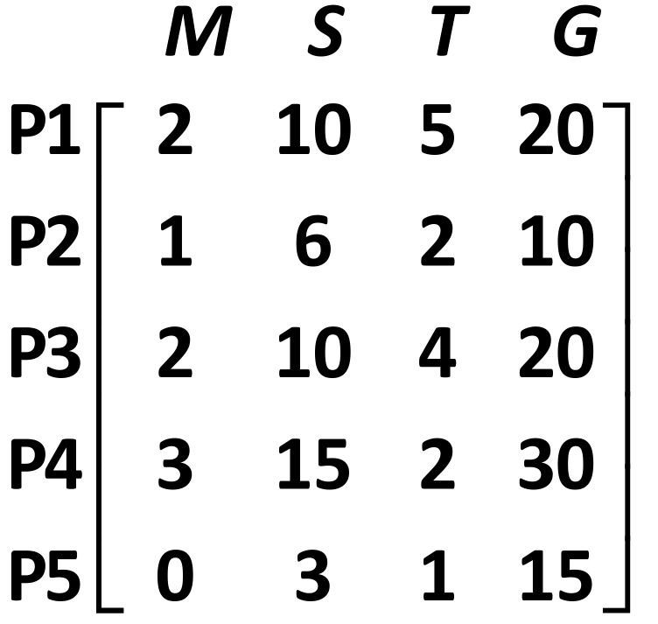

a) Write the column matrix, with rows representing in order M, S, T and G, that represents the

points for each way of scoring.

b) Show the matrix calculation needed to multiply the column matrix (from part a) by the matrix

provided for Question 6. Calculate this product.

c) What is the total score for P1? Where in the matrix from part b) is this score located?

d) Describe the data stored in the matrix generated in part b).